
A

Assignment

ON

“
INTERACTIVE WEB INTERFACES:HTML, CSS&
JAVA SCRIPT
”

BACHELOR OF

COMPUTER
APPLICATION

-
I

Sem

SESSION: 202
5
-
2
6

GUIDED BY:

SUBMITTED

BY:

Mrs.
Chetna
S
ahu

Name: Angel B M

)
Assit. Prof.
(

Erp No:RU-25-10189

SUBMITTED TO:

RUNGTA INTERNATIONAL SKILL UNIVERSITY, KOHKA BHILAI(C.G.)

1 Create an HTML page thet displays an image of your choice when a user on the image,it should redirect to your universitr website:
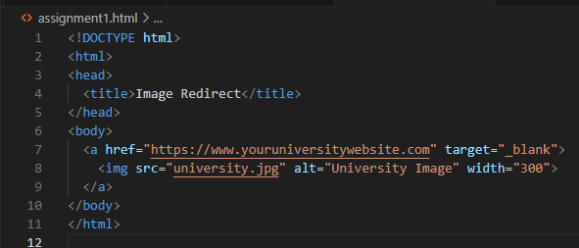
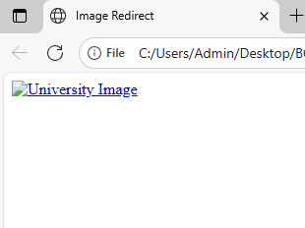

2 Design an HTML table to store students records with columns:roll no , marks,course,grade
Ensure the table has a heading row and at least 5 rows of data :
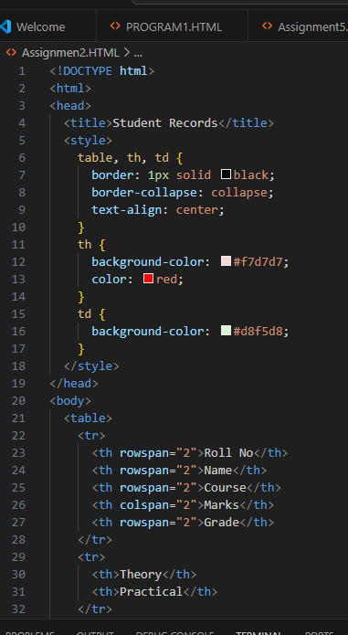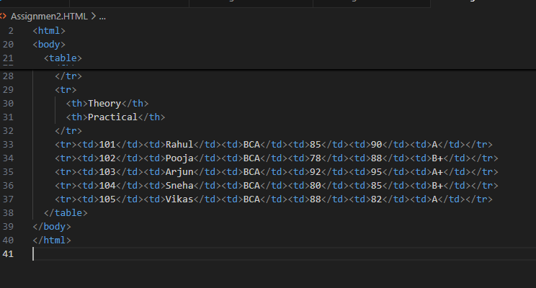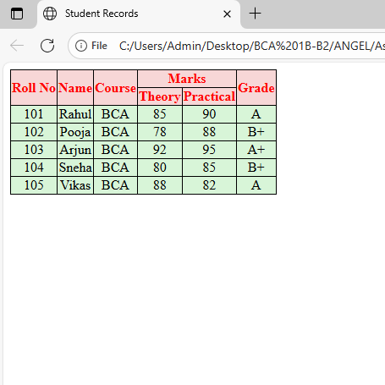
3 Build an HTML form that asks the user for their Name, Email,Gender(radio buttons) Favourite subject(dropdown) and comments(textarea) .Add a submit button.

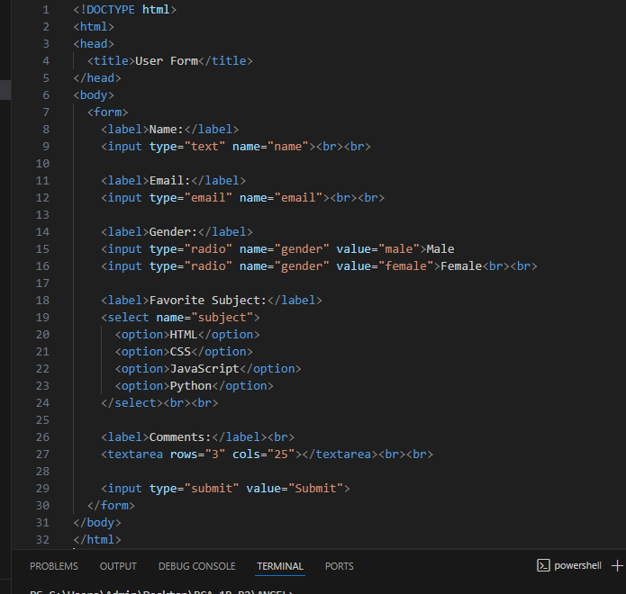
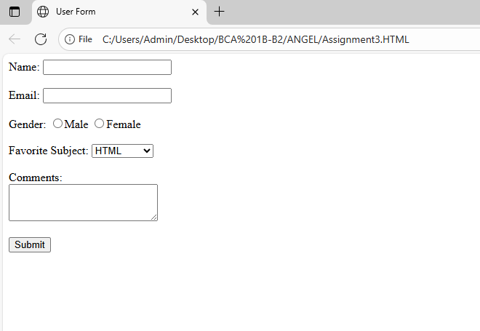

4 Create a simple navigation bar with links to Home,About,Courses and Contact using an unordered list(<ul>)
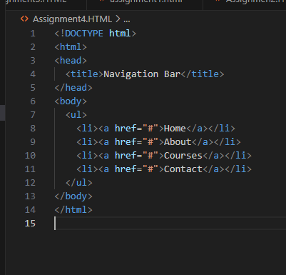
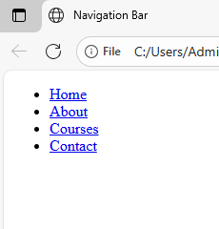

5 Design a webpage that embeds an audio file(mp3) and a videofile(mp4) with controls so that user can play/pause them.
